[SETTING UP APPLICATION ENVIRONMENT](https://careereducation.smartinternz.com/Student/guided_project_workspace/38367#collapse1)

**CREATE IBM CLOUD ACCOUNT**

|  |  |
| --- | --- |
| Date | 2 Nov 2022 |
| Team ID | PNT2022TMID18036 |
| Project Name | Smart Fashion Recommender Application |
| Team Members: | Ramyadevi RS  Samyuktha V  Srija J  Subiksha R |

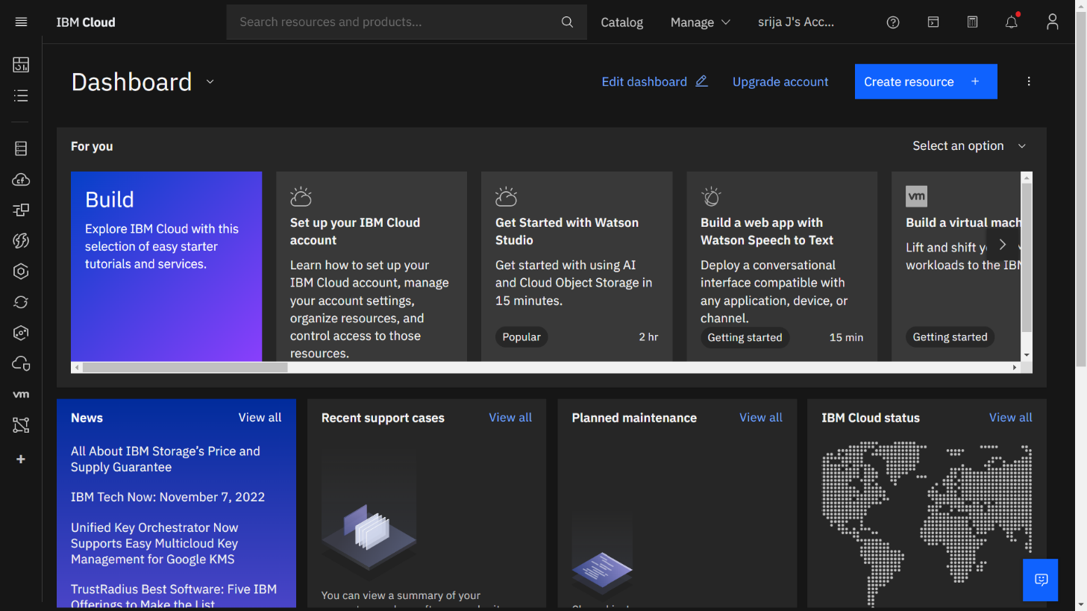

IBM Cloud Account has been created.